

**Assignment # 1**

**Digital Image Processing**

**Submitted To: Dr. Noman Islam**

**Submitted (Group)By:**

**Waleed Shaikh (11496)**

**Ayaz Qureshi (9910)**

**Mustansir Billah Asad Abbasi (9924)**

**Rashid Rahim (9715)**

Date: 2nd May 2018

**import math**

**#RGB TO HSI Color Code Conversion**

def RGB_TO_HSI(R,G,B):

Thita = math.acos(0.5*((R-G)+(R-B))/(((R-G)**2)+(R-B)*(G-B))**0.5)

S= (1-3/(R+G+B))*min(R,G,B)

I = 1/3 * (R+G+B)

if(B<=G):

H = Thita

else:

H = 360 - Thita

print("After Conversion InTo HSI")

print("*************************\n")

print("H :",H)

print("S :",S)

print("I :",I)

print("RGB TO HSI COLOR CONVERSION...")

print("===============================\n")

print("Enter RGB Values\n")

r = int(input("R: "))

g = int(input("G: "))

b = int(input("B: "))

RGB_TO_HSI(r,g,b)

***Output: -***

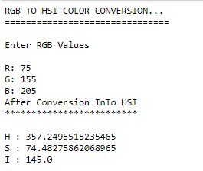

**#HSI TO RGB Color Code Conversion**

**import math**

def HSI_TO_RGB(H,S,I):

if(H>=0 and H<120):

R = I*(1+((S*math.cos(H))/math.cos(60-H)))

B = I*(1-S)

G = 1 - (R+B)

elif(H>=120 and H < 240):

H = H - 120

R = I*(1-S)

G = I *(1+(S*math.cos(H))/math.cos(60-H))

B = 1 - (R+G)

elif(H>=240 and H<360):

H = H - 240

G = I * (1-S)

B = I * (1 -((S*math.cos(H))/math.cos(60-H)))

R = 1 - (G+B)

else:

print("Wrong inputs")

print("After Conversion InTo RGB")

print("*************************\n")

print("R :",R)

print("G :",G)

print("B :",B)

print("HSI TO RGB COLOR CONVERSION...")

print("===============================\n")

print("Enter HSI Values\n")

h = int(input("H: "))

s = int(input("S: "))

i = int(input("I: "))

HSI_TO_RGB(h,s,i)

***Output: -***

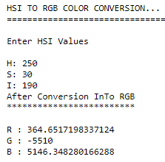

**#RGB TO CMYK Color Code Conversion**

def RGB_TO_CMYK(R,G,B):

C = 1 - (R/255)

Y = 1 - (G/255)

M = 1 - (B/255)

K = 1 - max(R,G,B)

print("After Conversion InTo CMYK")

print("*************************\n")

print("C :",C)

print("M :",M)

print("Y :",Y)

print("K :",K)

print("RGB TO CMYK COLOR CONVERSION...")

print("===============================\n")

print("Enter RGB Values\n")

r = int(input("R: "))

g = int(input("G: "))

b = int(input("B: "))

RGB_TO_CMYK(r,g,b)

***Output: -***

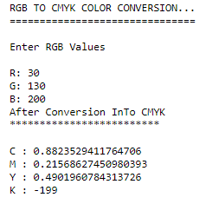

**#CMYK TO RGB Color Code Conversion**

def CMYK_TO_RGB(C,M,Y,K):

R = 255 * (1-C) * (1-K)

G = 255 * (1-M) * (1-K)

B = 255 * (1-Y) * (1-K)

print("After Conversion InTO RGB")

print("*************************\n")

print("R :",R)

print("G :",G)

print("B :",B)

print("CMYK TO RGB COLOR CONVERSION...")

print("===============================\n")

print("Enter CMYK Values\n")

c = int(input("C: "))

m = int(input("M: "))

y = int(input("Y: "))

k = int(input("K: "))

CMYK_TO_RGB(c,m,y,k)

***Output: -***

